1. . Define physics

………………………………………………………………………………………………..

1. . Write down all the branches of physics you know

…………………………………………………………………………………………….…….

…………………………………………………………………………………………………..

…………………………………………………………………………………………………..

………………………………………………………………………………………………….

1. . List down any four benefits of studying physics.

…………………………………………………………………………………………….……

…………………………………………………………………………….……………………

……………………………………………………………….…………………………………

………………………………………………….………………………………………………

1. . Write down any five careers (occupation undertaken) in Physics

………….………………………………………………………………………………………

…………………………………………………………………………….……………………

……………………………………………………………………….…………………………

………………………………………………………………….………………………………

…………………………………………………………………………………………………

1. . State any four ways we can always commonly apply knowledge of physics while at home

…………………………………………………………………………………………….……

…………………………………………………………………………….……………………

……………………………………………………………….…………………………………

………………………………………………….………………………………………………

1. . What is meant by the term a laboratory?

…………………………………………………………………………………………….……

…………………………………………………………………………….……………………

1. . Write down any four-laboratory apparatus you know in physics

…………………………………………………………………………………………….……

…………………………………………………………………………….……………………

……………………………………………………………….…………………………………

………………………………………………….……………………………………………

1. . What other name can you use to replace the word APPARATUS without changing its

Meaning ……………………………………………………………………………………....

1. . What is the laboratory apparatus?

............................................................................................

……………………………………………………………………………………………….

1. . List down any four safety precautions/measures taken while in the laboratory

…………………………………………………………………………………………….……

…………………………………………………………………………….……………………

……………………………………………………………….…………………………………

………………………………………………….………………………………………………

1. . As you moved around your school you must have noticed some other safety precautions /

measures taken by the school to ensure safety of the students. Write down any four safety

precautions you have noticed in your school.

…………………………………………………………………………………………….……

…………………………………………………………………………….……………………

……………………………………………………………….…………………………………

………………………………………………….………………………………………………

1. . Write down any four laboratory rules and regulations that must be followed while in the

laboratory

…………………………………………………………………………………………….……

…………………………………………………………………………….……………………

……………………………………………………………….…………………………………

………………………………………………….………………………………………………

1. . State two reasons why you should follow the laboratory rules and regulations

…………………………………………………………………………………………….……

…………………………………………………………………………….……………………

……………………………………………………………….…………………………………

………………………………………………….………………………………………………

1. . The mobile phones are some of the real-life applications of waves since it transfers

Information or DATA inform of electromagnetic waves from one place (source) to another

(Receiver). Name any other two machine or device that use knowledge of physics to operate

And in each case note down the topic applied by the device mentioned

Device 1…………………………………. Uses knowledge of…………………………………...

…………………………………. from topic called………………………………………………

Device 2………………………………… Uses knowledge of ……………………….…………

……………………………………………..from topic called……………………………………

SECTION B ATTEMPT ALL

ACTIVITY OF INTEGRATION

SCENARIO

The importance of physics in our lives is highlighted by the many applications that physics has

Made possible in people's lives, and which have become one of the indispensable necessities of

Life however most people are not aware of this significance especially our old grandparents.

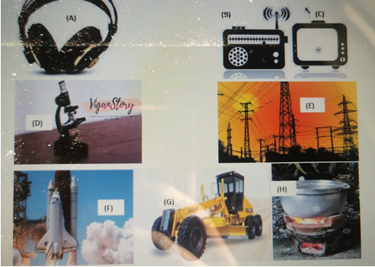

TASK

a) From the above highlighted images identify the activity in figures above and explain how

Physics helps in our daily life. In each case identify the figure, how it is applicable, and the

Branch of physics where the above figure falls under.

b) From pictures in A, B, C, D, E, F, G and H above write down the possible career opportunities

(Occupation undertaken) at the end of your education.

ACTIVITY OF INTEGRATION

SCENARIO

During the visitation at your school parents and guardians flooded the school compound and as

Part of school way of promoting their school to the outside community you are one of the few

Students selected to show the parents around the school laboratory. Whereas in the laboratory many

Apparatuses were organized to be displayed to the parents and guardians who were eagerly waiting

To see how well their learners have attained knowledge and skills while at school.

SUPPORT MATERIALS / RESOURCES

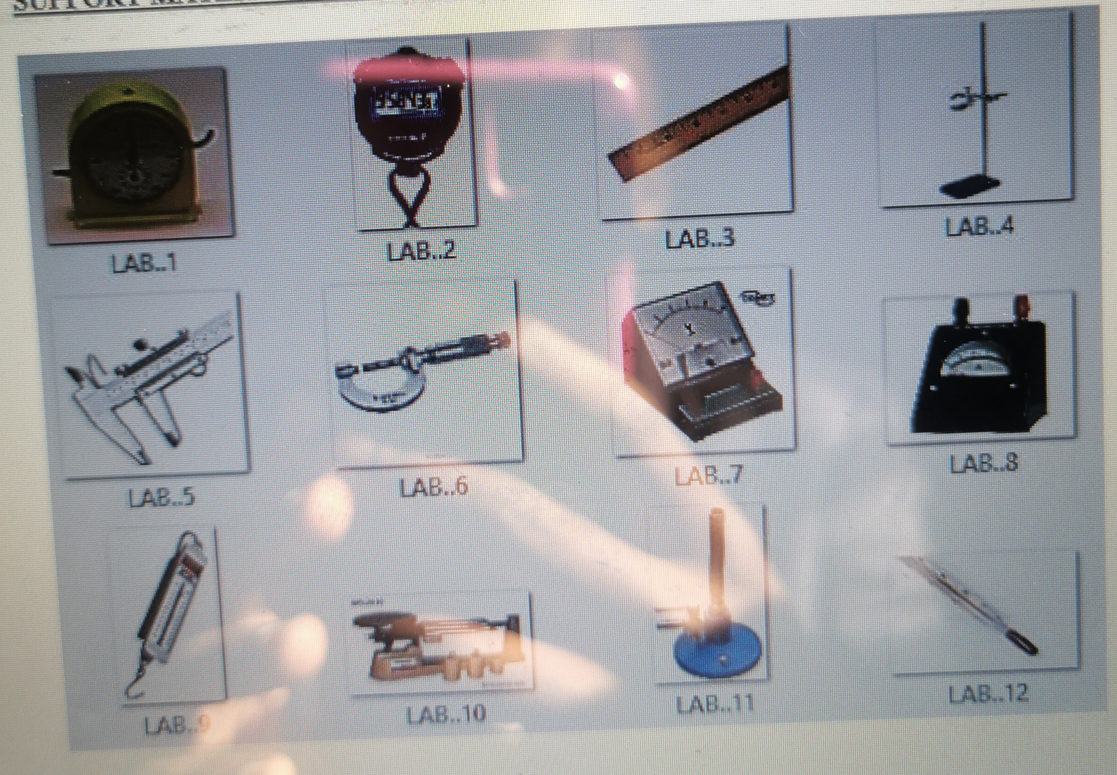

TASK

a) You have been selected as one of the few students to guide parents and guardians through

Laboratory Tour. Organize the speech you are going to present to the presents about the

Physics Laboratory and don’t forget to inform them of the rules and regulations they must

Abide by as they enter the laboratory for the tour.

b) As the second part of your presentation, you are required to organize each apparatus labelled

Above write down its name and briefly explain its real-life applications.

END